Task 2:

User inputted wrong number as an option

User inputs a number that is outside of the menu range. They receive error message and get sent back to the start of the menu loop



Uses an else statement so that if the user puts anything other than an option they get this message

User inputted a string instead of a number as option

User inputs a string instead of a number. They receive error message and get sent back to the start of the menu loop

Trys to convert user input to a number, if it doesn’t work they get error message and sent back to the top of the loop

Add song works

Asks user for song name, artist name and play count then adds it to the ArrayList

User selects option 1 and they then enter the songs information, this is sent to class Song_list where a new song is made from the Song class and added to the ArrayList

Remove song works

Asks user for song name and song artist and removes it from the ArrayList

User selects option 2 they then input the song name and artist name in. this is then checked against the array list and removes the Song if both arguments match and it says that it found the song

Remove song, song doesn’t exist

User inputs a song that doesn’t exist in the ArrayList so nothing is removed from it

Instead of a success message being displayed, nothing is displayed and nothing is removed from the Array list

Print all songs works

Prints all songs and all their information from the ArrayList

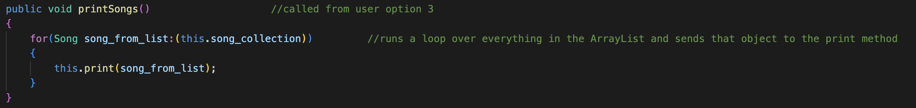

User selects option 3, the method printSongs is ran in Song_list class this loops over the whole ArrayList sending each Song object to the print method where each variable of the object is printed using the Song class’s methods

Print all songs above inputted number of plays works

Asks user for number of plays and prints all songs from the ArrayList with number of plays above the user’s number

User selects option 4 in the menu and is sent to the findSongs method in Song_list which loops over the ArrayList printing the songs (using the same method as option 3 above) checking if the plays is over what the user inputted

Quit program works

Exits the menu loop and displays an exit message



User selects option 5, it breaks the loop by setting run to false and displays an exit message

Loop back to menu after user choice executes

After user picks an option (not quit) and the option is ran, the user is sent back to the option select menu to select another option

After the code finishes running a previous option the while loop repeats and displays the menu again until the user chooses to quit the program

Create start songs

On program start, 10 songs are create and added to the array list which is also created

Code starts and crete_songs method is ran creating 10 songs from the song class, the Song_list object is also created and the songs are added using that

Link to GitHub repository (GitHub includes screenshots of code working and the code itself):

Code:

https://github.com/william-Cross12/University-folder/blob/main/module_1_programming_concepts/task_2/spotify_copy.java

everything:

https://github.com/william-Cross12/University-folder/blob/main/module_1_programming_concepts/task_2

Proof of existence:

